**Scala Programming**

**Name: CHETHAN Y**

**Use: 22BTRAD011**

**Collections:**

**Ranges:**

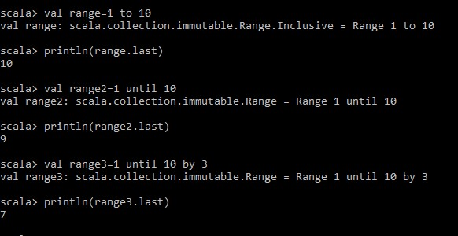

**Lists:**

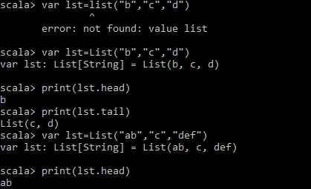

**Tuples:**

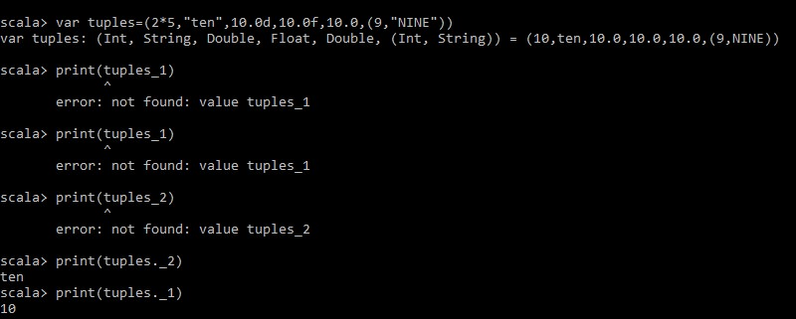

**Arrays-**

